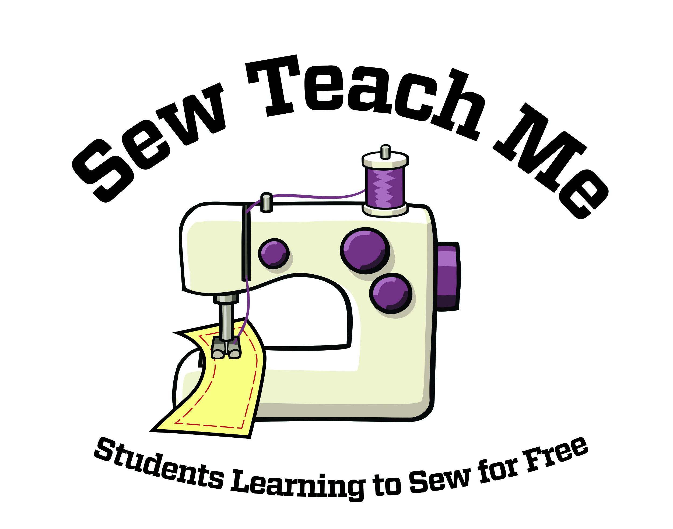
Sew Teach Me

As of Date, 2018

## Students

are in or through the Sew Teach Me Program

Thank you Mentors!

